**P2 - Identify communication protocols and models**

**Introduction**

In this report, I will be identifying protocols and I will give an example of a protocol and explain it. In addition, I will be explaining the each of the OSI and TCP/IP layers and comparing the similarities and differences of the models

**NETWORK PROTOCOL**

**Network protocol -** It’s within a computer, a communication protocol is a system which plays a part of exchanging messages within or between the computer. The main protocols that are involved in the OSI layer is the following: HTTP, TCP, IP, TCP/IP and Hardware. They are many types of protocols, but these are the main and simple protocols that people should know.

* **Token Passing**

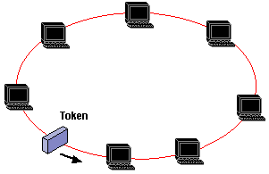Token passing is a communication protocol that is used in telecommunication. The token is a ‘message’ that is sent from one computer to another. Only one of the device sends it to another which enables communication. The device has to wait for it to be sent to the computer to enable communication with each other. An example of token passing is token ring and ARCNET. As the image presents how the token passing is being presented.

**Bluetooth** uses the same principles as 3G and Wi-Fi. Depending on the device that the user is using, you will find that Bluetooth vary. It can be used for PAN (Personal Area Network. They are three different types of Bluetooth:

* Bluetooth can communicate over a distance of 100 metres
* Bluetooth used on mobile phones, 10 metres
* Bluetooth used hands-free, 1 metre

All these devices use Bluetooth; only the distance that differs.

**OSI and TCP/IP Model**

**Application Layer** makes the request to the other application you sent it to. HTTP is the common that any person would know. This stands for Hypertext Transfer Protocol. HTTP should take in response to any commands. For example, when you type in the URL the web page, it sends messages to the direct page for it to be done.

**Presentation Layer** takes care of any issues that occur during the process. It only takes care of any data that is complete only in the application layer. This manages the compression and encryption.

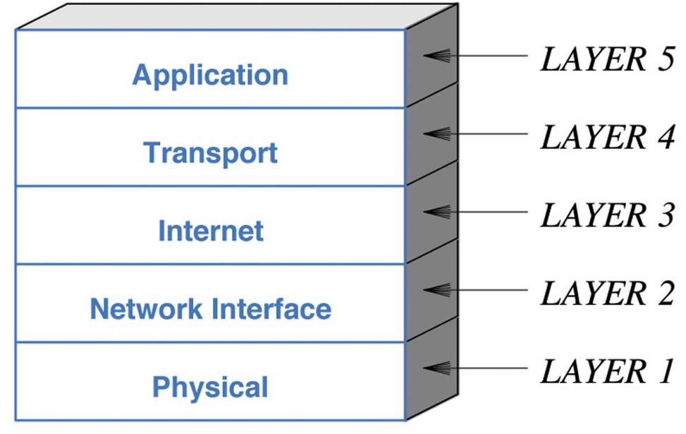**Session Layer manages** to open, close and manage a session between the processes. In between the session layer, it has sockets. Sockets have two types, stream sockets and datagram sockets. Stream sockets is a type of internet socket that transmits data on a regular basis. Datagram sockets is a type of connectionless network socket, which is sending or receiving points – relating to session layer.

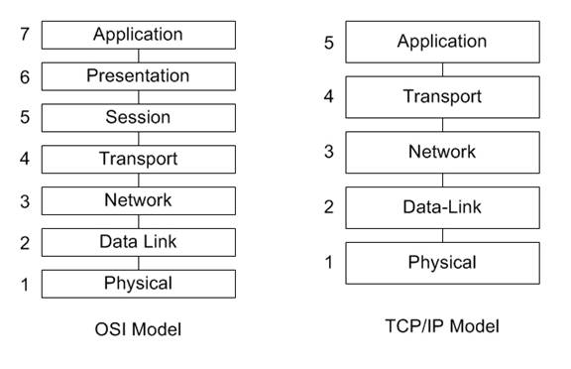**Transport Layer** does all the transportation. TCP stands for Transmission Control Protocol. TCP is reliable, error-checked delivery from one point to another.

Figure 1.3

**Internet Layer** or IP layer is method that uses datagram to communicate through another network. It sends short messages. Each computer has its own unique IP address. It uses the IP routers to transmit data.

**Network Interface Layer** commonly refers to the data link layer. This receives the end package of the communication. This could include IEEE 802.2. The main aim of this layer is to provide trustable communication between the networks. This layer is important as it may cause security issues. One of the ways network interface layer does the data link is through Ethernet. Ethernet is a wire that commonly connects the computer to your router. It can connect Laptops to each other, so the internet connects perfectly.

**Physical layer (layer 1)** does the raw bits of all the communication throughout the layers. Physical aspects could be through wires, coax cable. Wirelessly communication could be slower as it sends signals, just like Bluetooth, to the other network and sends the data.

ONCE THIS LAYER IS COMPLETE, IT HAS TO GO THROUGH THE SAME STAGE FOR THE WHOLE PROCESS TO BE COMPLETE.

**Similarities and differences of OSI and TCP/IP Model**

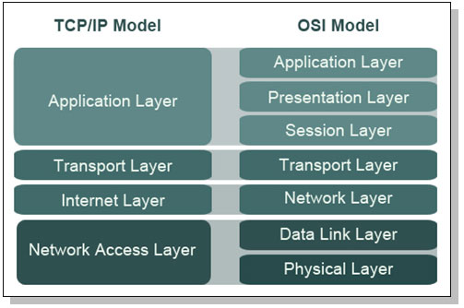The difference between the two models is that TCP/IP has five layers, whereas OSI has seven layers. They both work the same and they are the same thing. However, OSI is more detailed. The similarities for both is that they work in the same way. The message goes through all of these layers and it goes back up the same way. It is just the extension of it. This image shows the demonstration of the layers.

**M1 – Explain why communication protocols are important**

**Introduction**

In this assignment, I will be explaining the importance of protocols. I will show some examples of protocols and explain them. In addition, I will be explaining the history of protocols and what would happen if they were not used.

**The importance of protocols**

Protocol is the main base of communication.It’s within a computer, a communication protocol is a system which plays a part of exchanging messages within or between the computer. The importance of protocols is that it is the basic backbone instruction for moving information from one location to another. This uses the hardware that is used for communication. Without the protocols, we would not be able to communicate and only verbally, we would. However, this would be communication but the other user would not tell what the other person is saying. Both of the protocols need to understand with each other. For example, if we in London spoke to someone in Brazil, we would not understand what he or she are saying. This is similar in protocol. They need to “speak the same language” in order to communicate. It is important in the protocol word as once this happens, we can send messages to other people. The best structure that the protocols follow is the OSI and TCP/IP model. They are many protocols, but I will be naming the most common protocols that is used. These three are the following are:

**Common Protocols**

* HTTP

Hypertext Transfer Protocol (HTTP) is a protocol that is found on the address bar that does two jobs. The first job is that it allows the user to access the information that is on the page and the other is that it transfers hypertext to the server when the process of communication is enabled.

* FTP

File Transfer Protocol (FTP) is a protocol that helps us transfer or receive information from one computer to another. This protocol can be used for other types of jobs and it is used in data types and other programming languages.

* SMTP/POP3

Simple Mail Transfer Protocol (STMP) and Post Office Protocol are two different protocols, but they have the similar tasks to do. STMP helps us when the email has been delivered and received. This job is at the beginning or end of the process. POP3 allows the user to download content from the email. As you know, both of the jobs are in the ‘email’ part and it is important.

As you know the examples above, it shows the jobs that they to in order for two users to communicate with each other. They all have specific jobs to do and it is important for them to be protocols. Simply, without them, we would not be able to communicate.

**Reference M1**

**BTEC LEVEL 3 BOOK UNIT 9 CHAPTER**

[**http://en.wikipedia.org/wiki/Protocol_(computing)**](http://en.wikipedia.org/wiki/Protocol_(computing))

[**http://en.wikipedia.org/wiki/Hypertext_Transfer_Protocol**](http://en.wikipedia.org/wiki/Hypertext_Transfer_Protocol)

[**http://www.hmailserver.com/documentation/latest/?page=whatis_pop3imapsmtp**](http://www.hmailserver.com/documentation/latest/?page=whatis_pop3imapsmtp)

**D1 – Compare the OSI seven layer model and the TCP/IP model**

**Introduction**

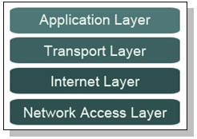In this assignment, I will be comparing the OSI and TCP/IP model. In addition, I will be naming the features and uses of it.

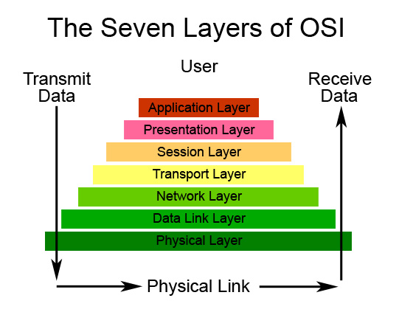

**Comparing the OSI and TCP/IP models**

OSI stands for Open System Interconnection and TCP/IP stands for Transmission Control Protocol and Internet Protocol. The difference between the two models is that TCP/IP has five layers, whereas OSI has seven layers. They both work the same and they are the same thing. This means that whatever happens on the OSI model between the transportation of data, it happens on the TCP/IP Layer. All we need to know is that they are both the same, but OSI is more detailed of how the data is transported. Without this, we would not know how communication works with two computers and how they are transported. As you can see figure 1.1, OSI has the additional layers of presentation layer, session layer, data link layer and physical layer. These are not any different from the TCP/IP model. It is split into sections for OSI and the OSI is more detailed of how the communication works between two computers.

Figure 1.1

**Features and uses of TCP/IP and OSI model**

**Layer 1 – Application Layer (TCP/IP) 🡪 Presentation, Session and Application Layer (OSI)**

Application Layer makes the request to the other application the user sends it. HTTP is the common that any person would know. This stands for Hypertext Transfer Protocol. HTTP should take in response to any commands. For example, when you type in the URL the web page, it sends messages to the direct page for it to be done. Presentation Layer takes care of any issues that occur during the process. It only takes care of any data that is complete only in the application layer. This manages the compression and encryption. Session Layer manages to open, close and manage a session between the processes. In between the session layer, it has sockets. Sockets have two types, stream sockets and datagram sockets. Stream sockets is a type of internet socket that transmits data on a regular basis. Datagram sockets is a type of connectionless network socket, which is sending or receiving points – relating to session layer.

**Layer 2 – Transport Layer (TCP/IP and OSI)**

Transport Layer simply does all the transportation. TCP stands for Transmission Control Protocol. TCP is reliable, error-checked delivery from one point to another.

Figure 1.3

**Layer 3 – Internet Layer (TCP/IP) 🡪 Network Layer (OSI)**

Internet Layer (IP) of the TCP/IP layer is method that uses datagram to communicate through another network. It sends short messages. Each computer has its own unique IP address. It uses the IP routers to transmit data. Network Interface Layer commonly refers to the data link layer. This receives the end package of the communication. This could include IEEE 802.2. The main aim of this layer is to provide trustable communication between the networks. This layer is important as it may cause security issues. One of the ways network interface layer does the data link is through Ethernet. Ethernet is a wire that commonly connects the computer to your router. It can connect Laptops to each other, so the internet connects perfectly.

**Layer 4 – Network Access Layer (TCP/IP) 🡪 Physical and Data Link Layer (OSI)**

Network Access Layer of the TCP/IP layer does the last bit of it, which it receives, the data or transports it. Physical layer does the raw bits of all the communication throughout the layers. Physical aspects could be through wires, coax cable. Wirelessly communication could be slower as it sends signals, just like Bluetooth, to the other network and sends the data. The data link layer of the OSI model gets the information of the network layer and issues it to request it on to the physical layer. The data link is responsible for encoding the bits into packets.

**References D1**

BTEC Book page: 314- 315, 316-317

<http://quizlet.com/13365480/unit-1-understanding-how-networks-communicate-flash-cards/>

<http://ictsmksh.blogspot.co.uk/2010/07/introduction-to-computer-networks-and.html>

<http://users.telenet.be/mydotcom/library/network/netintro.htm>

<http://www.pctecmech.com/networking/How-Do-Computers-Communicate.php>